

Project Title: | IoT Smart Monitoring System
Course: | Embedded IoT Systems
Project Title: | IoT-Based Smart Traffic and Toll Management System Using ESP32 and Blynk
Group Name: | Tech X
Group Members: | Ibtisam Butt (23-NTU-CS-1269)  Saim Mustafa (23-NTU-CS-1271)  Shahzaman Dhillon (23-NTU-CS-1273)
Instructor name: | Sir Nasir Mehmood
Submission date | December 21,2025

Problem Statement:
Traditional traffic control systems operate on fixed time intervals and do not consider real-time vehicle density. This results in traffic congestion, unnecessary delays, and inefficient road usage. To overcome these problems, an automated and intelligent traffic management system is required that can dynamically control traffic signals based on real-time conditions.
In addition, toll plazas also require automated gate control to reduce congestion and manual effort. Therefore, this project also integrates an automated toll gate using IR sensor and servo motor.

Objectives:
The main objectives of this project are:
- To design a smart traffic management system using ESP32.
- To detect vehicle density using IR sensors.
- To automatically control traffic lights based on traffic load.
- To integrate a smart toll plaza using IR sensor and servo motor.
- To provide real-time monitoring and control using Blynk cloud platform.
- To implement automatic and manual control modes via mobile application.
- To reduce congestion and improve traffic flow.

System Architecture:
The system is based on ESP32 microcontroller which acts as the main control unit. Three IR sensors are installed on traffic lanes to detect vehicle density, while an additional IR sensor is used at the toll plaza. Traffic lights are controlled using LEDs, and a servo motor is used to operate the toll gate. The ESP32 connects to the Blynk cloud through WiFi, allowing real-time monitoring and control via a mobile application.

Hardware Components
- ESP32: Main controller with built-in WiFi for IoT communication.
- IR Sensors (3): Detect vehicle presence on traffic lanes.
- Toll IR Sensor (1): Detects vehicles at toll gate.
- LEDs (Red, Yellow, Green): Represent traffic signals for each lane.
- Servo Motor: Opens and closes the toll gate automatically.
- Resistors (220Ω): Protect LEDs from overcurrent.
- Power Supply (5V): Provides power to the system.
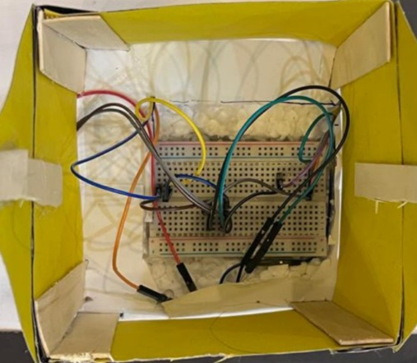
- Jumper Wires / PCB: Used for circuit connections.
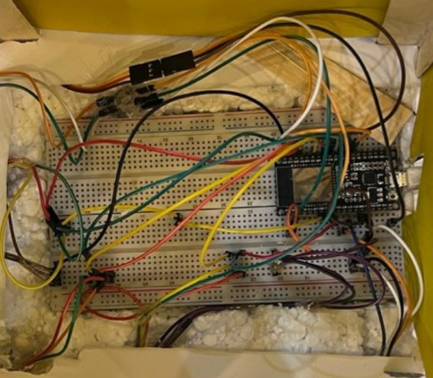
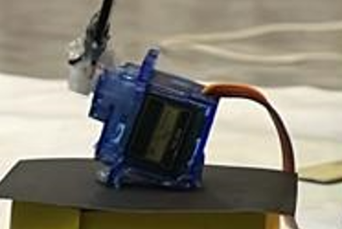
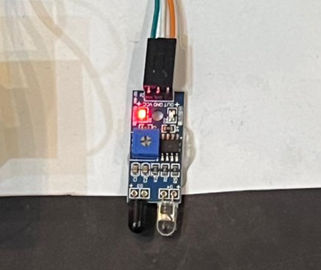
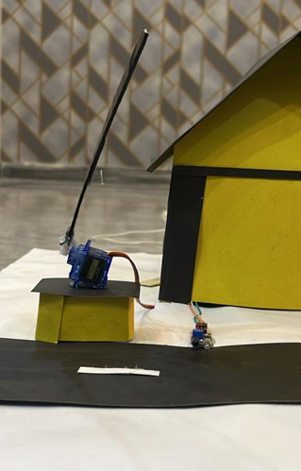
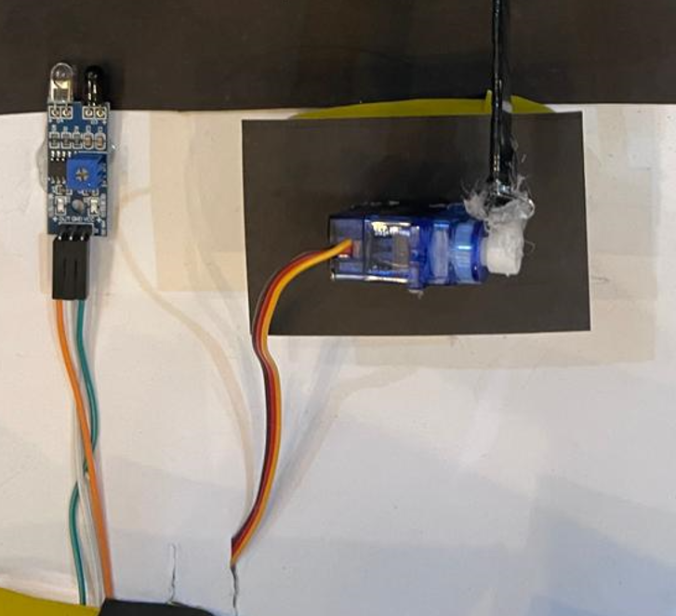
Software Tools Used
- Arduino IDE: Used to program the ESP32.
- ESP32 Board Package: Enables ESP32 programming.
- WiFi Library: For wireless communication.
- WebServer / ESPAsyncWebServer: For dashboard creation.
- HTML & CSS: Used to design the web dashboard.
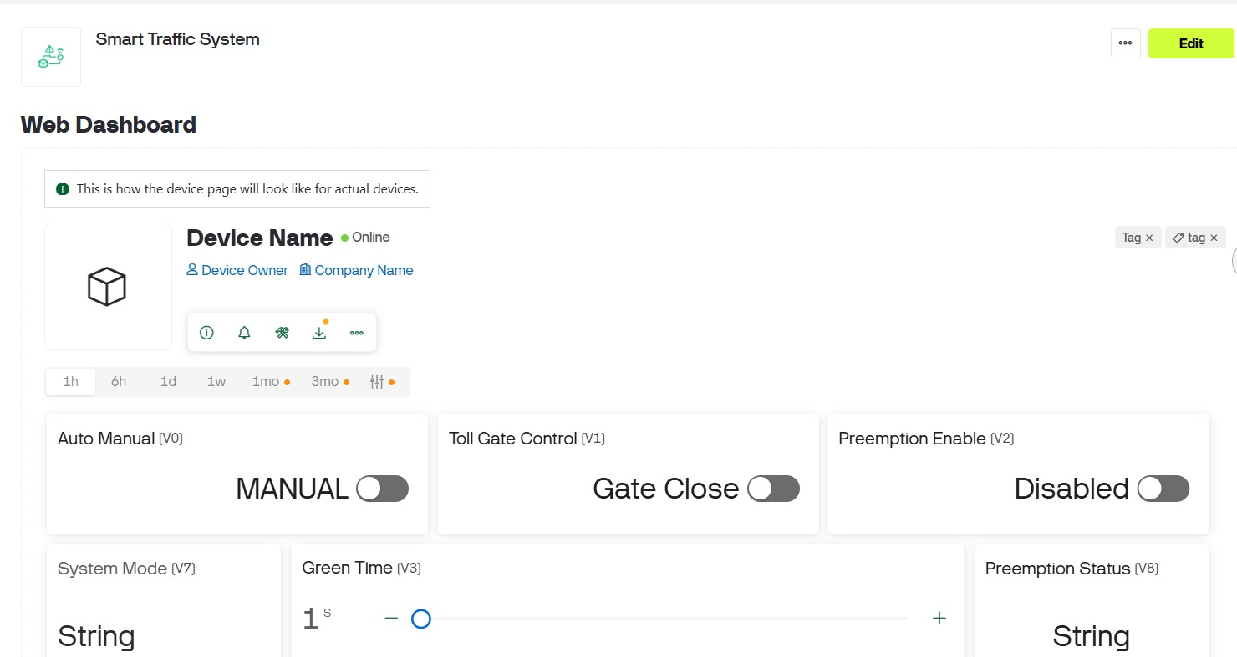
- Debounce Logic: Eliminates false sensor readings.
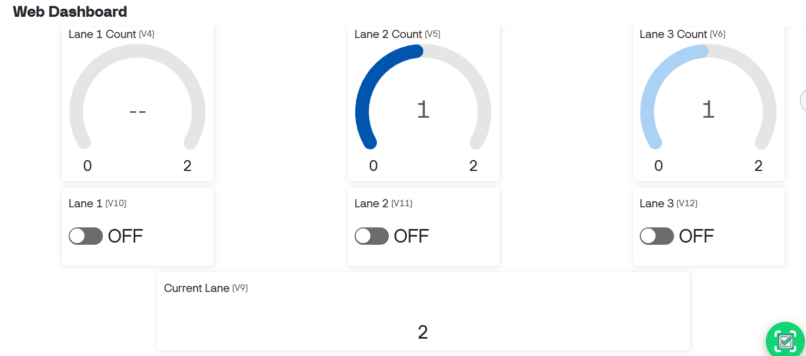

Working of the System

- Traffic System Working:
- IR sensors detect vehicles when traffic signal is red.
- Vehicle count increases for the detected lane.
- ESP32 compares traffic density of all lanes.
- Lane with higher traffic is given green signal.
- A safety all-red delay is applied before switching.
- Vehicle counter resets when the lane turns green.

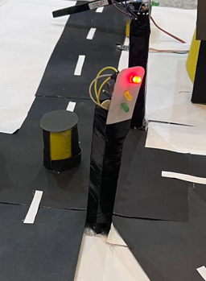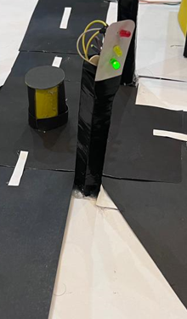

- Toll Plaza Working
- Toll IR sensor detects vehicle arrival.
- Servo motor opens the gate automatically.
- Gate remains open for 5 seconds.
- Gate closes automatically.
- Manual control is available through Blynk app.

Circuit Explanation
IR sensors are connected to ESP32 GPIO pins as inputs using internal pull-up resistors. Traffic LEDs are connected through 220Ω resistors to ESP32 output pins. The servo motor is connected to GPIO pin 4 for toll gate control. All components share a common ground and are powered by a 5V supply.

Hardware Implementation
The hardware is assembled using ESP32, IR sensors, LEDs, resistors and servo motor. Traffic signals change automatically based on vehicle density, and the toll gate opens and closes correctly using the servo motor.
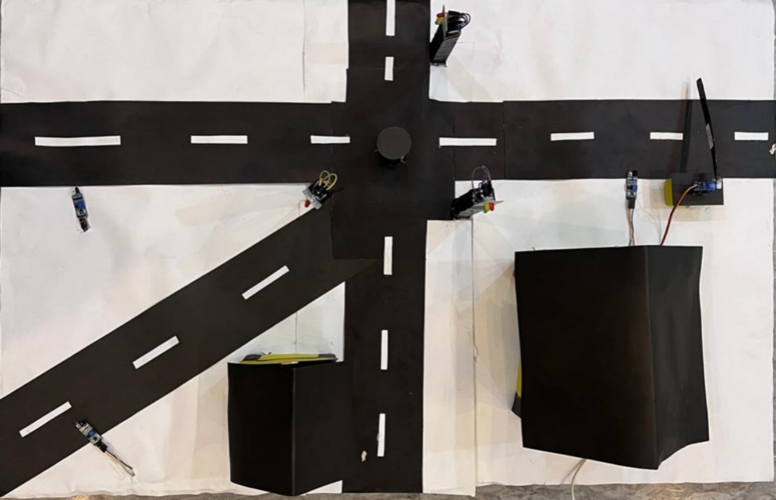

Results
- Vehicles are detected accurately using IR sensors.
- Traffic signals respond dynamically to traffic density.
- Toll gate automation works efficiently.
- Blynk app displays real-time lane data and system status.
- Both automatic and manual modes function correctly.
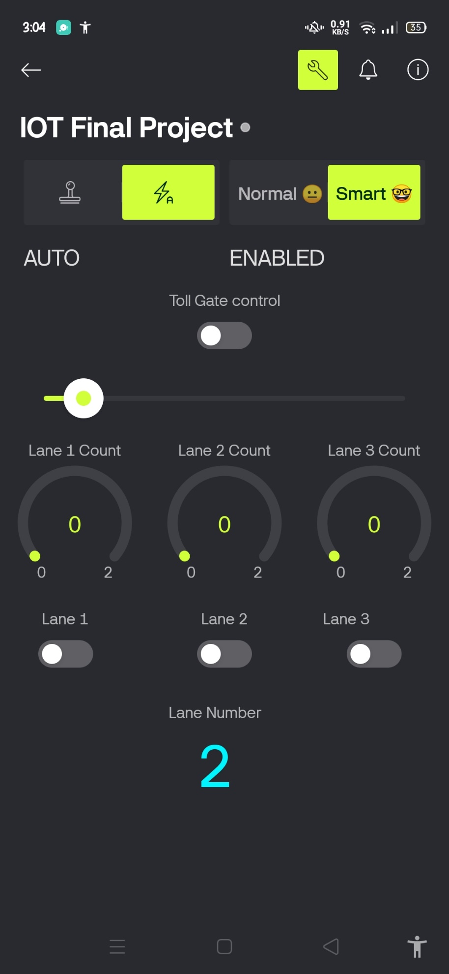
Conclusion
The IoT-Based Smart Traffic & Toll Management System successfully demonstrates intelligent traffic control and automated toll operation using ESP32 and Blynk cloud platform. The system meets all project objectives and provides a practical real-world solution.
Future Scope
- Camera-based vehicle detection
- Cloud data storage
- Emergency vehicle priority system
- Mobile application integration
- Multi-toll and multi-intersection expansion

